Database Management (資料庫管理) - Spring 2026 (114
-2)
Assignment 5. Structured Query Language (SQL)

Consider the northwind_simple database as follows.
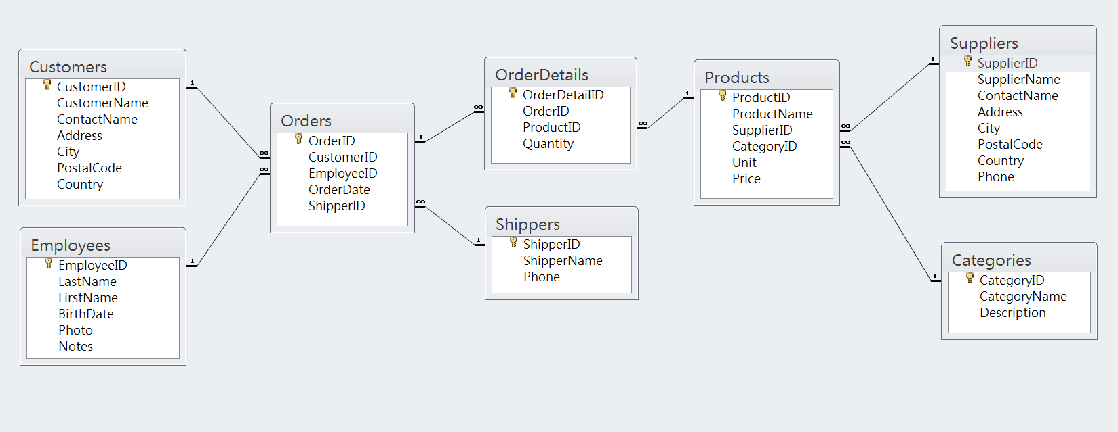
- The Access database can be downloaded in the following link
http://www1.pu.edu.tw/~jsyeh/1142/DBM/databaseSample/northwind_simple.accdb

- The Northwind database can also be tested online http://www.w3schools.com/sql/trysql.asp?filename=trysql_select_all

Answer the following questions in terms of SQL statements

- List the all customer in UK and order the result by City and PostalCode.

Result:
Number of Records: 7
CustomerName | ContactName | Address | City | PostalCode | Country
Island Trading | Helen Bennett | Garden House Crowther Way | Cowes | PO31 7PJ | UK
B's Beverages | Victoria Ashworth | Fauntleroy Circus | London | EC2 5NT | UK
Seven Seas Imports | Hari Kumar | 90 Wadhurst Rd. | London | OX15 4NB | UK
North/South | Simon Crowther | South House 300 Queensbridge | London | SW7 1RZ | UK
Around the Horn | Thomas Hardy | 120 Hanover Sq. | London | WA1 1DP | UK
Consolidated Holdings | Elizabeth Brown | Berkeley Gardens 12 Brewery | London | WX1 6LT | UK
Eastern Connection | Ann Devon | 35 King George | London | WX3 6FW | UK

- List the Category and the total number of Products in the Category.

Result:
Number of Records: 8
Category | Number of Products in The Category
Beverages | 12
Condiments | 12
Confections | 13
Dairy Products | 10
Grains/Cereals | 7
Meat/Poultry | 6
Produce | 5
Seafood | 12

- Find the top 10 best-selling products in terms of quantity.

Result:
Number of Records: 10
Product | Product Sold
Gorgonzola Telino | 458
Camembert Pierrot | 430
Steeleye Stout | 369
Raclette Courdavault | 346
Chang | 341
Pavlova | 338
Fløtemysost | 336
Alice Mutton | 331
Tarte au sucre | 325
Geitost | 316

- List all customers’ names and the total number of orders by the customers.

Result:
Number of Records: 91
Customer Name | Total numbers of Orders
Alfreds Futterkiste | 0
Ana Trujillo Emparedados y helados | 1
Antonio Moreno Taquería | 1
Around the Horn | 2
B's Beverages | 1
Berglunds snabbköp | 3
Blauer See Delikatessen | 0
Blondel père et fils | 4
Bon app' | 3
…

