Database Management (資料庫管理) - Spring 2026 (114-2)
Assignment 4 Normalization of Database Tables

1. The dependency diagram in Figure Q6.8 indicates that a patient can receive many prescriptions for one or more medicines over time. Based on the dependency diagram, create a database whose tables are in at least 2NF, showing the dependency diagram for each table.
Figure Q6.8Prescription Dependency Diagram
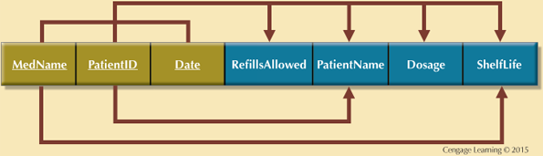

Given the dependency diagram shown in Figure Q6.6.

Figure Q6.6 Dependency Diagram
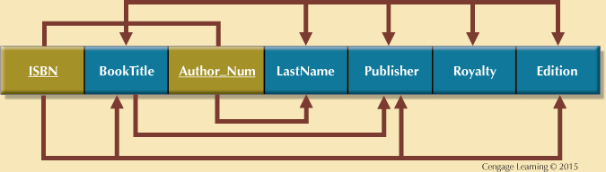

- Identify and discuss each of the indicated dependencies.
- Create a database whose tables are at least in 2NF, showing the dependency diagrams for each table.
- Create a database whose tables are at least in 3NF, showing the dependency diagrams for each table.

