Database Management (資料庫管理) - Spring 2026 (114-2)
Assignment 2 Data Model

- Using Figure P2.6 as your guide, work Problems 1–2. The Tiny College relational diagram shows the initial entities and attributes for the college.
Figure P2.6 The Tiny College Relational Diagram
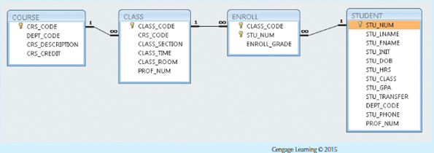

Create the basic Crow’s Foot ERD for Tiny College.

Hint:
- A course can have many classes.
- A class is associated with only one course.

- Write the business rules that are reflected in the ERD shown in Figure P2.15. (Note that the ERD reflects some simplifying assumptions. For example, each book is written by only one author. Also, remember that the ERD is always read from the “1” to the “M” side, regardless of the orientation of the ERD components.)
Figure P2.15 The Crow’s Foot ERD for Problem 15
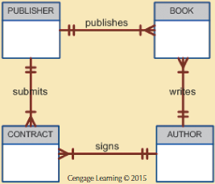
Hint:
- A publisher can publish one or many books.
- A book is published by one and only one publisher.

- Describe the relationships (identify the business rules) depicted in the Crow’s Foot ERD shown in Figure P2.13.
Figure P2.13 The Crow’s Foot ERD for Problem 13
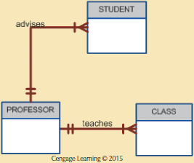
Hint:
- A professor can advise one or many students.

- [加分思考題]
Figure P2.15 的ERD有無改進或調整的建議?
(若使用生成式 AI，請註明所使用之工具與提示詞（prompt），並確認輸出結果之正確性。)

