**Database Management (資料庫管理) - Spring 2025 (113-2)**

**Assignment 4 Normalization of Database Tables**

1. The dependency diagram in [Figure Q6.8](javascript://) indicates that a patient can receive many prescriptions for one or more medicines over time. Based on the dependency diagram, **create a database whose tables are in at least 2NF, showing the dependency diagram for each table.**

**Figure Q6.8Prescription Dependency Diagram**

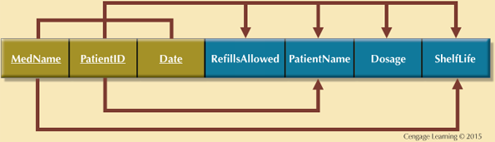

Given the dependency diagram shown in Figure Q6.6.

Figure Q6.6 Dependency Diagram

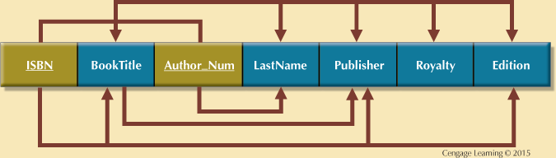

1. Identify and discuss each of the indicated dependencies.
2. Create a database whose tables are at least in 2NF, showing the dependency diagrams for each table.
3. Create a database whose tables are at least in 3NF, showing the dependency diagrams for each table.