**Database Management (資料庫管理) - Spring 2025 (114-2)**

**Assignment 3 ER Modeling**

1. The local city youth league needs a database system to help track children who sign up to play soccer. Data need to be kept on each team, the children who will play on each team, and their parents. Also, data need to be kept on the coaches for each team.

**Draw the following data model with the entities and attributes** described here.

**Entities required:**

**Team, Player, Coach, and Parent**

**Attributes required:**

**Team:** Team ID number, Team name, and Team colors

**Player:** Player ID number, Player first name, Player last name, and Player age

**Coach:** Coach ID number, Coach first name, Coach last name, and Coach home phone number

**Parent:** Parent ID number, Parent last name, Parent first name, Home phone number, and Home Address (Street, City, State, and Zip Code)

**The following relationships must be defined:**

* 1. Team is related to Player.
  2. Team is related to Coach.
  3. Player is related to Parent.

**Connectivities and participations are defined as follows:**

* 1. A Team may or may not have a Player.
  2. A Player must have a Team.
  3. A Team may have many Players.
  4. A Player has only one Team.
  5. A Team may or may not have a Coach.
  6. A Coach must have a Team.
  7. A Team may have many Coaches.
  8. A Coach has only one Team.
  9. A Player must have a Parent.
  10. A Parent must have a Player.
  11. A Player may have many Parents.
  12. A Parent may have many Players.

**Your task:**

**Draw the database model in both Chen’s Model and Crow’s Foot Model(兩種模型都需要)**

2. Use the database shown in [Figure P3.10](javascript://)

**Figure P3.10 The Ch03_BeneCo Database Tables**

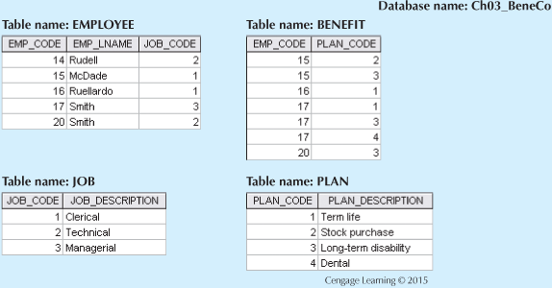

* An EMPLOYEE has only one JOB_CODE, but a JOB_CODE can be held by many EMPLOYEEs.
* An EMPLOYEE can participate in many PLANs, and any PLAN can be assigned to many EMPLOYEEs.

Note also that the M:N relationship has been broken down into two 1:M relationships for which the BENEFIT table serves as the composite or bridge entity.

**Your task:**

**Draw the database model in both Chen’s Model and Crow’s Foot Model(兩種模型都需要)**