**Database Management (資料庫管理) - Spring 2025 (113-2)**

**Assignment 2 Data Model**

1. Using [Figure P2.6](javascript://) as your guide, work Problems 1–2. The Tiny College relational diagram shows the initial entities and attributes for the college.

**Figure P2.6 The Tiny College Relational Diagram**

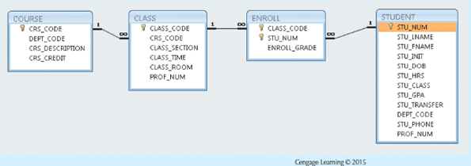

Create the basic Crow’s Foot ERD for Tiny College.

**Hint:**

* A course can have many classes.
* A class is associated with only one course.

1. Write the business rules that are reflected in the ERD shown in [Figure P2.15](javascript://). (Note that the ERD reflects some simplifying assumptions. For example, each book is written by only one author. Also, remember that the ERD is always read from the “1” to the “M” side, regardless of the orientation of the ERD components.)

**Figure P2.15 The Crow’s Foot ERD for Problem 15**

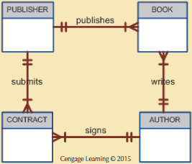

**Hint:**

A publisher can publish one or many books.

1. Describe the relationships (identify the business rules) depicted in the Crow’s Foot ERD shown in [Figure P2.13](javascript://).

**Figure P2.13 The Crow’s Foot ERD for Problem 13**

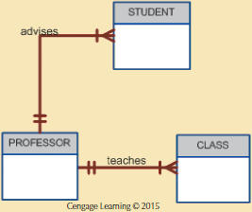

**Hint:**

* A professor can advise one or many students.